INDEX No. :______________

MILITARY COLLEGE OF SIGNALS
FINAL EXAMINATION – (BESE – 14)
NUMBER THEORY

Instructor: Dr Saeed Murtaza Date: January 15, 2011
Max Time: 150 min Max Marks: 50

Note
- Attempt all questions in the given sequence. Any out of the sequence solution will get you no credit.
- Understanding question is the part of examination.
- Show complete working, i.e., do not leave any thing for the instructor to assume on your behalf.
- There are no marks for the procedure only.
- Attach question paper with the answer sheet.

Question No. 1:
- Prove that every positive integer greater than 1 has a prime divisor.
- Goldbach conjectured that every odd positive integer greater than 5 is the sum of three primes. Verify this conjecture for 101 and 97.
[2+2]
Question No. 2:
Use Mathematical Induction to prove that 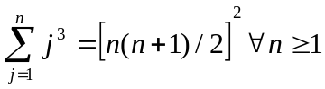
[3]
Question No. 3:
- If a and b are positive integers both not zero and 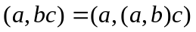then prove that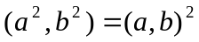.
- Prove that if a, b, and n are positive integers, then 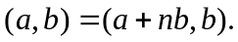
[3+2]
Question No. 4:
A man bought a dozen pieces of fruit – apples and oranges – for Rs. 99.00. If an apple costs Rs. 3.00 more than an orange and he bought more apples than oranges, how many of each did he buy?
[3]
Question No. 5:
Show that if a, b, c, and d are integers such that b and d are positive, (a,b) = (c,d) = 1 and a/b + c/d is an integer, then b = d.
[4]
P. T.O

Question No. 6:
A postal clerk has only 14- and 21- cents stamps to sell. What combinations of these may be used to mail a package requiring postage of exactly $4.00 ($1 = 100 cents).
[3]
Question No. 7:
- When “n” is divided by 8, the remainder is 5. What is the remainder of the division of 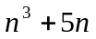by 8?
- What will be the remainder when 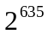is divided by 537.
[3+4]
Question No. 8:
Find the least positive residue of 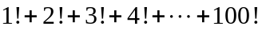modulo 25.
[3]
Question No. 9:
- Show that if 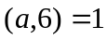and , then 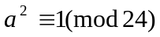
- Suppose that 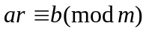 and that 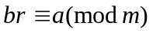for some integer r. Show that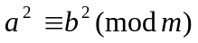. Give an example of integers 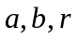and m, when integers a, b, r, and m ≠ 1, that satisfy this result.
[3+2+2]
Question No. 10:
Using Chinese Remainder Theorem, find all integer solutions of following system of linear congruences 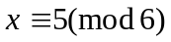, 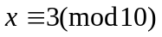and 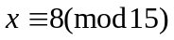
[5]
Question No. 11:
A parking lot has 67 parking places. A total of 200 parking stickers are sold and only 30 – 50 vehicles are expected to be parked at any time.
- Set up a hashing function and collision resolution policy for assigning parking places based on license plates displaying six-digit number.
- Allocate parking places to 15 cars having following license plate numbers.

258442, 652847, 798540, 128487, 459786, 124561, 658246, 111288, 271842, 250648, 200597, 100080, 497029, 240642, 120422

[2+4]

